MSci Project PHYS4015/4024

Laboratory Based Working: Supervision Agreement

Project Title: Automated Optical Absorption System

Students: Harry Spratt & Jake Hurley

Internal Supervisor(s): Mohamed Henini

Module Convenor for this project: Prof Kent

Location for this experimental work: School of Physics & Astronomy

Laboratory staff member: Matt Young

The following have been agreed by all parties:

- Laboratory and/or technical staff are aware of the various requirements of this project. E.g. space and equipment.
- All aspects of the project have been discussed with supervisors/convenor
- Work will not be carried out in a laboratory without staff in attendance/nearby
- Students are aware of local area rules and emergency procedures
- Work will not be carried out without all safety documentation being complete and local copies being available
- Adequate training has taken place for use of all equipment

Additional Notes:

Signed:
Laboratory Staff
Student 1 | Student 2
 | 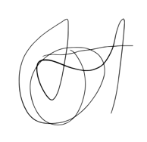
Student 3 | Supervisor

